

NPM Assignment

Installation Process

Aug 20, 2021

# 

# Introduction & Background

NPM(Node Package Manager) is package manager for node JavaScript platform. Its puts modules in place so that node can

Finds and manages commonly it is used to publish, discover ,install and develop node programs.

1. Anguler
2. React
3. Vue
4. Ionic

# Nodejs Installation

I have installed the latest version of nodejs. if you want to install the latest version go to this link - <https://github.com/nodesource/distributions/blob/master/README.md>

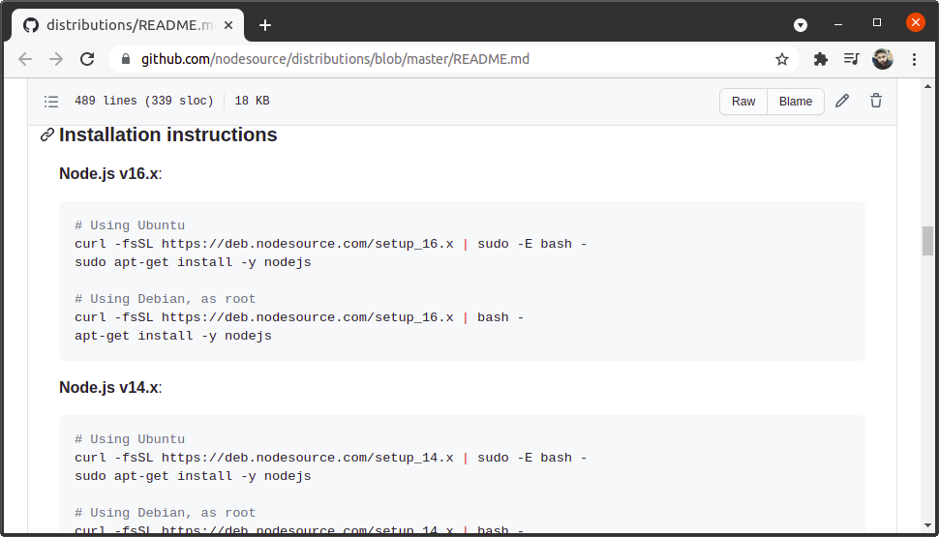

Step 1 :- open terminal and run this command -> curl -fsSL https://deb.nodesource.com/setup_16.x | sudo -E bash -

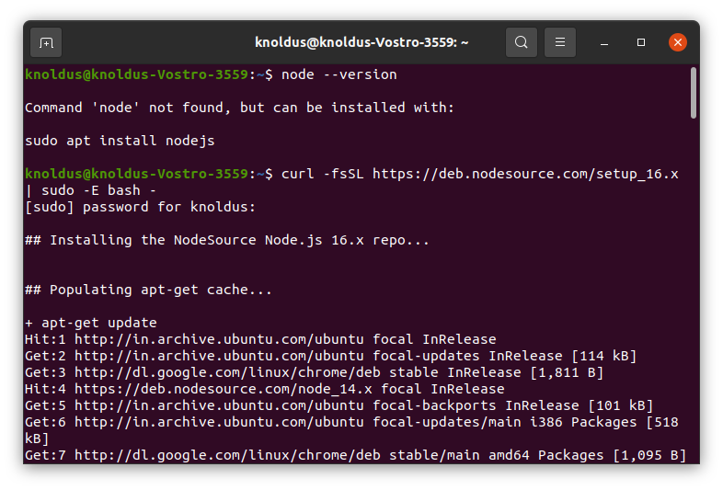00

Step 2:- Step 2:- sudo apt-get install -y nodejs

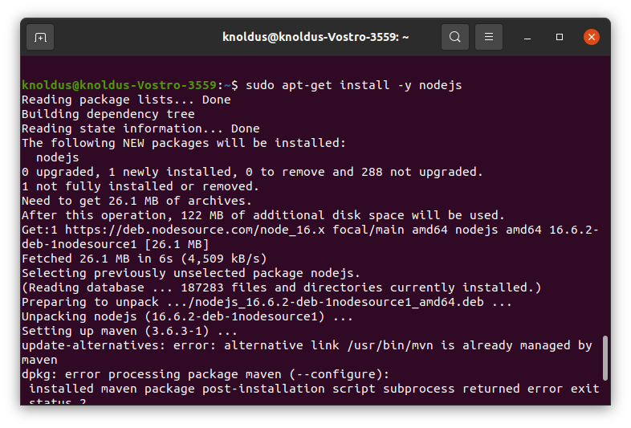

Step 3 :- Check version of nodejs run this command -> node --version

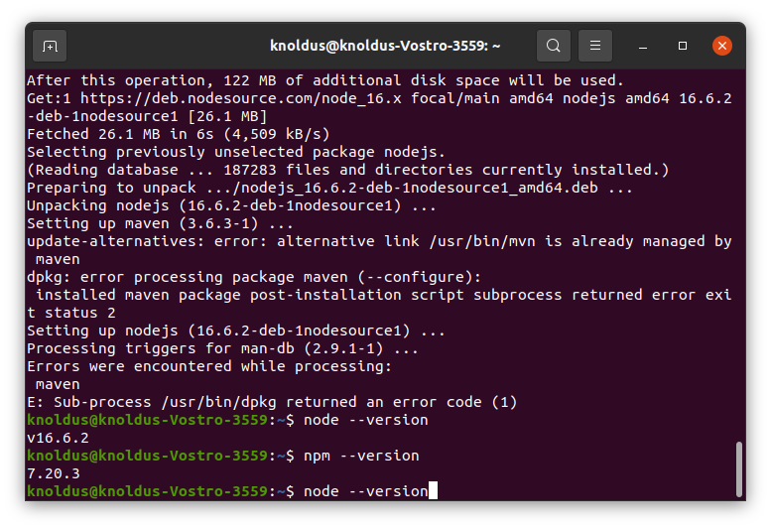

Version v16.6.2

When you install nodejs using this process you will automatically install npm(Node Package Manager).

# Angular Installation

When we run this command -> npm install -g @angular/cli . So it showing Error: EACCES: permission

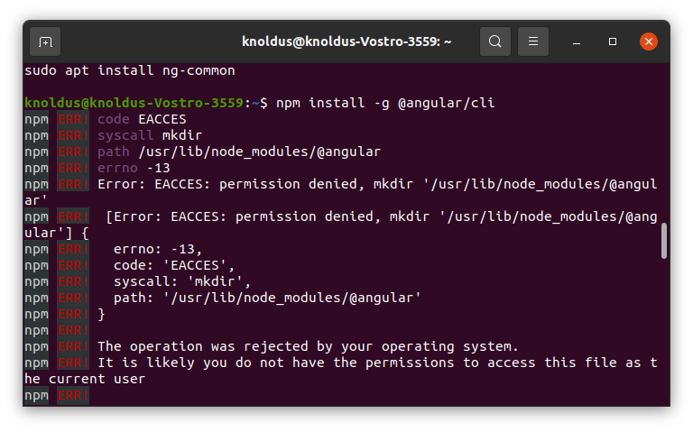

Step 1 ;- To change the permissions run this command -> sudo chown -R root:knoldus /usr/lib/node_modules/

Step 2 :- sudo chmod -R 775 /usr/lib/node_modules/



Step 3 :- sudo npm install -g @angular/cli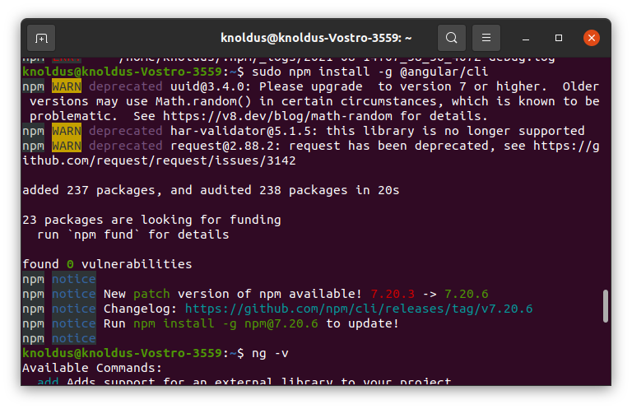

Step 4:- ng -version

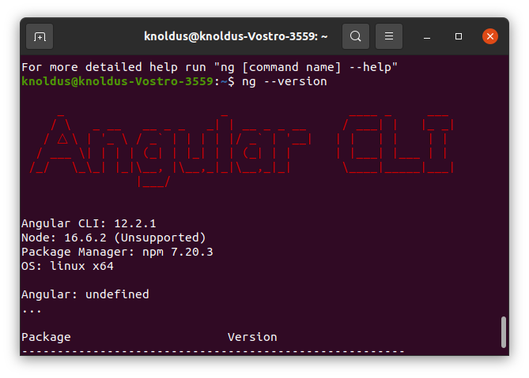

# React Installation

Step 1:- sudo npm install -g create-react-app

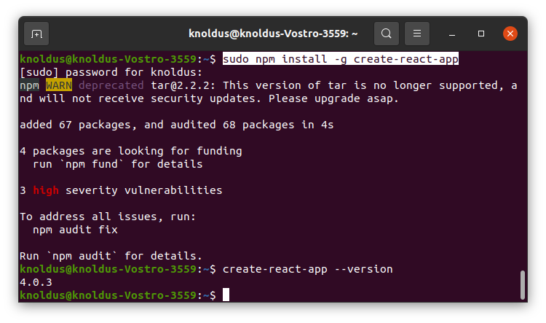

# Vue Installation

Step 1 :- sudo npm install -g @vue/cli

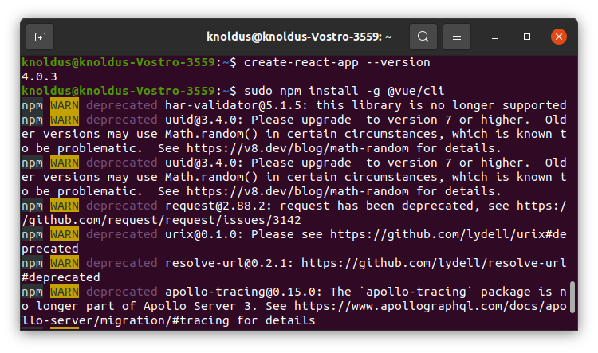

Step 2 :- vue --version

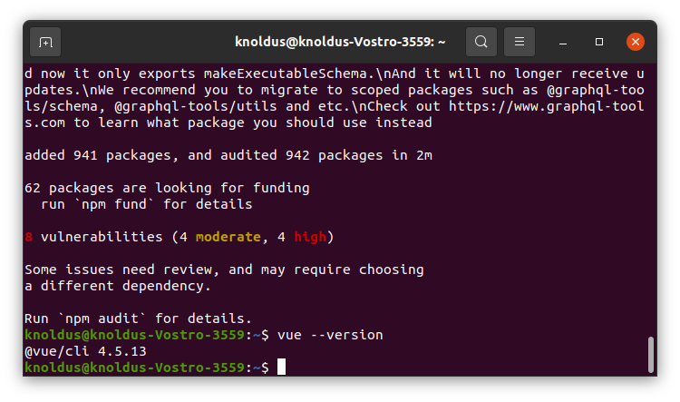

# Ionic Installation

Step 1:- sudo npm install -g @ionic/cli

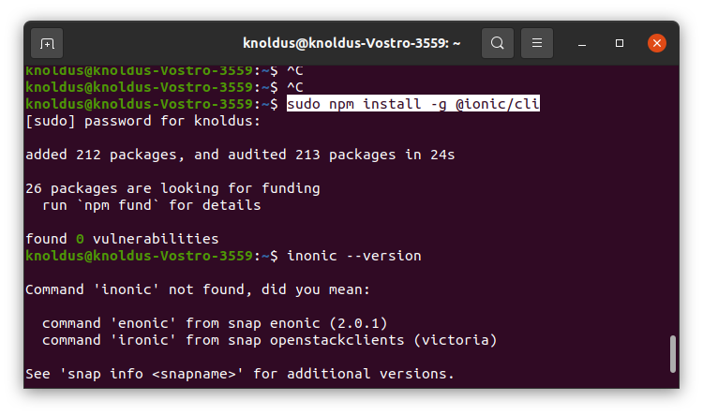

Step 2:- ionic --version

